Exercise 1:

1. Run hello-world

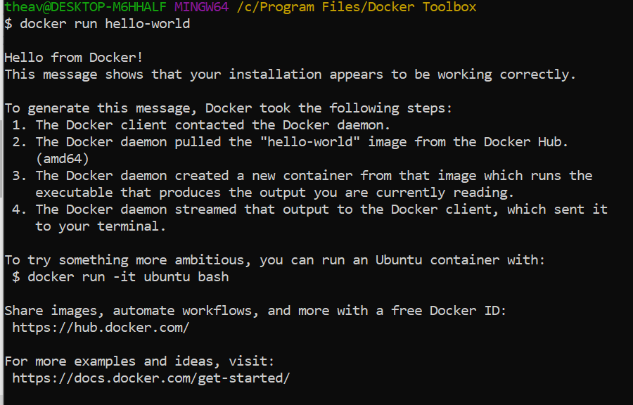

1. **docker images**

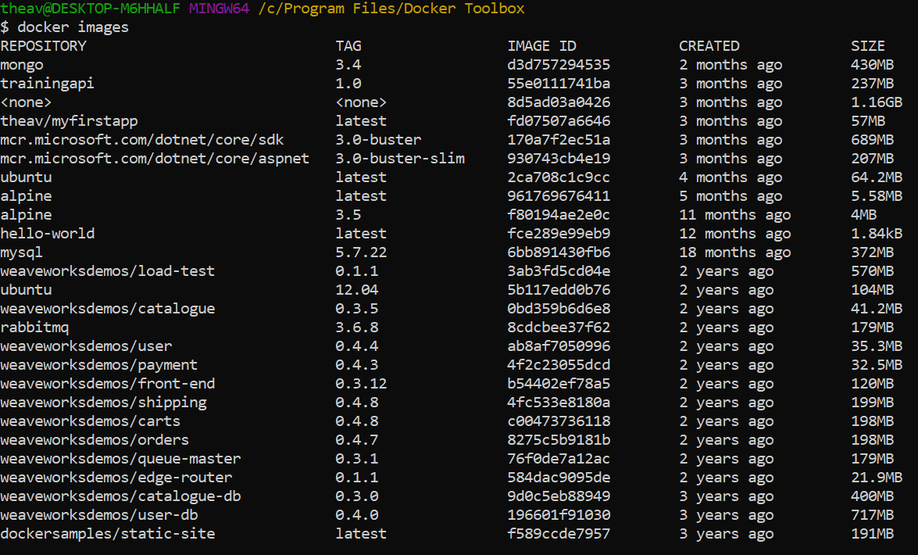

1. **docker ps -a**

